AP BIO Chapter 12, 13, 15, 16, and 17 Exam Review
Chapter 12: Mitosis/Cell Cycle
What are the parts to the cell cycle? What happens during each?
What are the phases of Mitosis? What happens during each phase? What do they look like?
How do cell cycles for a plant and animal differ?
How is the cell cycle regulated? What point will cause the cell cycle to go to completion?
What is apoptosis? How does it take place in a cell?
Calculate the chi square for samples of onion root tip cells at three different temperatures if the sample at 10°C had 135 in interphase and 56 in mitosis and the sample at room temperature had 156 in interphase and 23 in mitosis and the sample at 40°C had 170 in interphase and 18 in mitosis.

Chapter 13: Meiosis and Sexual Life Cycles
What is a karyotype?
What are the phases of Meiosis I and Meiosis II? What happens during each phase? What do they look like?
What is the difference between a gamete and a zygote? What process leads to each?
What is the difference between haploid and diploid? What types of cells are each found in?
How are Mitosis and Meiosis similar? different?
How does genetic variation occur during Meiosis?

Chapter 15: The Chromosomal Basis of Inheritance
What is nondisjunction? What happens if it occurs during Meiosis I? What about Meiosis II?
What is aneuploidy? Which example is the most severe?
What are inversions and translocations? How do they occur?
How are map units related to cross over frequency?
Calculate the map units a gene is from the centromere if in a sample of organisms 65 displayed cross over and 25 did not.
Chapter 16: DNA/The Molecular Basis of Inheritance
What functional group are DNA made of, how are they put together and what kind of bonds join the different parts?
What are the roles of DNA Polymerase III, DNA Polymerase I, Ligase, Helicase, RNA primer, and telomerase in DNA replication?
What determines the nucleotide sequence for a new strand of DNA?
How do leading strand and lagging strands differ?
What is the difference between heterochromatin and euchromatin?
What is the transformation of bacteria?
What direction is DNA synthesized?

Chapter 17: From Gene to Protein/Protein Synthesis
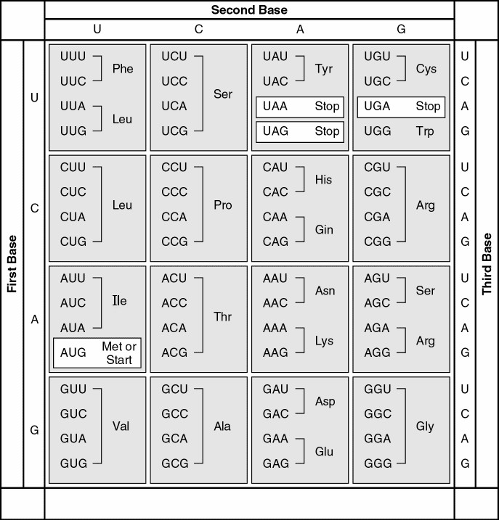
If there was a sequence of amino acids such as Arg-Glu-Val-Cys, what would the sequence of DNA that coded for them?
mRNA codons

What about if there was a sequence of mRNA codons such as ACUCAUGGAUUAUGA, what amino acids would they code for?
What are the roles of the TATA box, promotor, transcription factors, RNA polymerase, introns, exons, slicesosomes, 5' cap, Poly A tail, in Protein Synthesis and where are they found?
What type of bonds cause tRNA to be the odd shape that it is?
What are the steps of transcription and translation?
What is reverse transcription?
What is a polyribosome?
What are the different types of mutations? Which ones have the most serious effects?
How does protein synthesis differ in prokaryotes and eukaryotes?

