AP Chemistry Thermochemistry and Gas Law Exam Review

1) The value of for the reaction below is -126 kJ. The amount of heat that is released by the reaction of 25.0 g of with water is __________ kJ.
A) 20.2 B) 40.4 C) 67.5 D) 80.8 E) -126

Is the reaction endothermic or exothermic? How do you know? What does that mean? What is happening at the particle level for this to be true? Which bonds/forces are stronger? How do you know?

2) The specific heat capacity of liquid mercury is 0.14 J/g-K. How many joules of heat are needed to raise the temperature of 5.00 g of mercury from 15.0 °C to 36.5 °C?
A) 72 B) 15.1 C) 65 D) 8.1 E) 6.6

If a hot metal was placed in a container of water at room temp, what would happen to the temperature and the energy transfer of each substance?

3) Given the following reactions
ΔH = 66.4 kJ
ΔH = -114.2 kJ
the enthalpy of the reaction below of the nitrogen and oxygen to produce nitric oxide
is __________ kJ.

A) 180.6 B) -47.8 C) 47.8 D) 90.3 E) -180.6

4) Given the data in the table below, for the reaction below is __________ kJ.

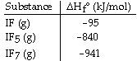

A) 1801 B) -1801 C) 121 D) -121 E) -101

5) For which one of the following reactions is the value of equal to for the product?
A) B)
C) D)
E)

6) Using the table of bond dissociation energies, the for the following gas-phase reaction is __________ kJ.
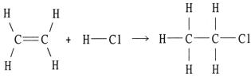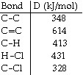

A) -44 B) 38 C) 304 D) 2134 E) -38

7) Of the possible bonds between carbon atoms (single, double, and triple), __________.
A) a triple bond is longer than a single bond
B) a double bond is stronger than a triple bond
C) a single bond is stronger than a triple bond
D) a double bond is longer than a triple bond
E) a single bond is stronger than a double bond

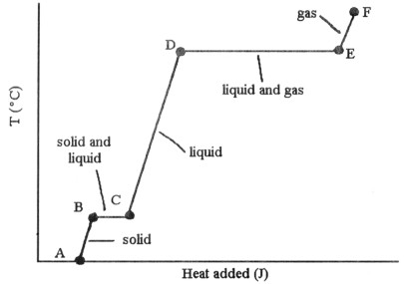
8) The heating curve shown above was generated by measuring the heat flow and temperature for a solid as it was heated. The slope of the __________ segment corresponds to the heat capacity of the solid.
A) AB B) BC C) CD D) DE E) EF

Why is more energy needed at DE than at BC?

If this graph was for water how would it compare to a graph of CO₂? Why?

What influences the amount of heat of fusion and heat of vaporization for a particular substance?

9) The fluorocarbon has a normal boiling point of 47.6 °C. The specific heats of and are 0.91 J/g-K and 0.67 J/g-K, respectively. The heat of vaporization of the compound is 27.49 kJ/mol. The heat required to convert 50.0 g of the compound from the liquid at 5.0 °C to the gas at 80.0 °C is __________ kJ.

A) 8.19 B) 1454 C) 30.51 D) 3031 E) 10.36
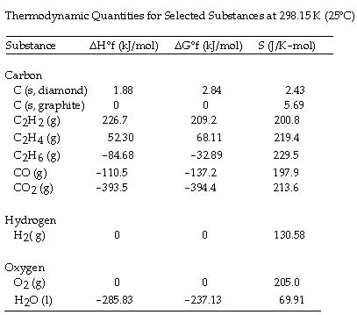
10) The combustion of acetylene in the presence of excess oxygen yields carbon dioxide and water:
The value of for this reaction is __________ J/K∙ mol.
A) +689.3 B) +122.3 C) +432.4 D) -122.3 E) -432.4

11) is positive for the reaction __________.
A) B)
C) D)
E)

What is happening to the entropy of the universe?

12) The value of at 100.0 °C for the formation of calcium chloride from its constituent elements:
is __________ kJ/mol. At 25.0 °C for this reaction, is -795.8 kJ/mol, is
-748.1 kJ/mol, and is
A) -855.4 B) -736.1 C) D) -779.8 E)

Is this reaction thermodynamically favored? What is causing it to be this way? How would changing the signs of ΔHº and ΔSº affect this?

13) A vessel contained N₂, Ar, He, and Ne. The total pressure in the vessel was 987 torr. The partial
pressures of nitrogen, argon, and helium were 44.0, 486, and 218 torr, respectively. The partial
pressure of neon in the vessel was __________ torr.
A) 42.4 B) 521 C) 19.4 D) 239 E) 760

How do you does pressure relate to number of particles? How does pressure relate to volume?

How does pressure and volume affect kinetic energy if temp is kept constant?

14) A real gas will behave most like an ideal gas under conditions of __________.
A) high temperature and high pressure B) high temperature and low pressure
C) low temperature and high pressure D) low temperature and low pressure
E) STP

15) A 0.875 L flask filled with gas at 1.014 atm and 29 °C contains __________ mol of gas.
A) 3.6 X 10⁻² B) 0.37 C) 9.42 D) 12.4 E) 80.7

What measurements must be taken to calculate molar mass of a substance when it is a gas collected over water?

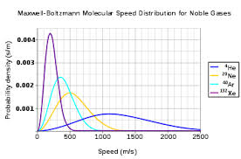
Which line shows the particle with the greatest mass? What about the highest average temperature?

How does mass affect diffusion and effusion rates?

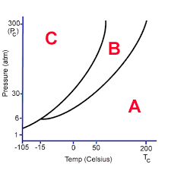
What does A, B and C stand for? What phase is the substance in at 30 atm and 200°C? What happens when the substance is cooled to -15°C?

1) A 2) B 3) A 4) E 5) D 6) A 7) D

8) A 9) E 10) E 11) C 12) B 13) D 14) B
15) A

