Chemical Bonding Worksheet

Ionic Bond between a Metal and Non-Metal (M + NM)
Covalent Bond between a Non-Metal and Non-Metal (NM + NM)
Metallic Bond between a Metal and Metal (M+ M)

Determine if the elements in the following compounds are metals or non-metals. Describe the type of bonding that occurs in the compound.

Compound | Element 1  (metal or non-metal?) | Element 2  (metal or non-metal?) | Bond Type
NO₂ | N = non-metal | O = non-metal | covalent
NaCl
SO₂
PO₄³⁻
MgBr₂
CaO
H₂O
K₂O
Cu-Zn alloy
O₂
CuCl₂
NO₂⁻
TiO₂
HF
Rb₂S
Au-Ag mixture
Fe₂O₃
C₆H₁₂O₂₂

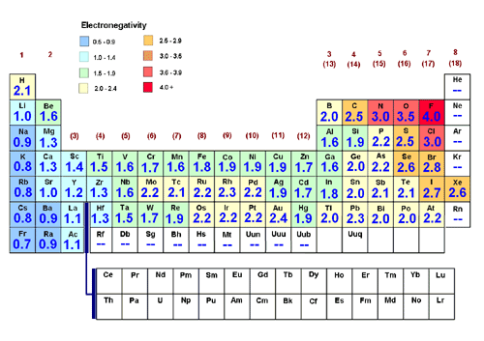

Difference in electronegativity
4.0 1.7 .4 0
Ionic | Polar-covalent bond | Non-polar covalent bond
100% 50% 5% 0%
Percentage Ionic character

Bonding between | More  electronegative element and value | Less  electronegative element and value | Difference in electronegativity | Bond Type
Sulfur and
Hydrogen
Sulfur and
cesium
Chlorine and
bromine
Calcium and
chlorine
Oxygen and
hydrogen
Nitrogen and
hydrogen
Iodine and
iodine
Copper and
sulfur
Hydrogen and
fluorine
Carbon and
oxygen

